**Jenkins Assignments**

**Easy Assignment: "Create and Monitor a Basic Jenkins Pipeline"**  
Objectives:

* Set up a simple Jenkins pipeline
* Navigate key Jenkins interface elements
* Monitor build status and logs
* Understand basic Jenkins configuration

### Deliverables:

1. **Screenshot of your Jenkins dashboard**

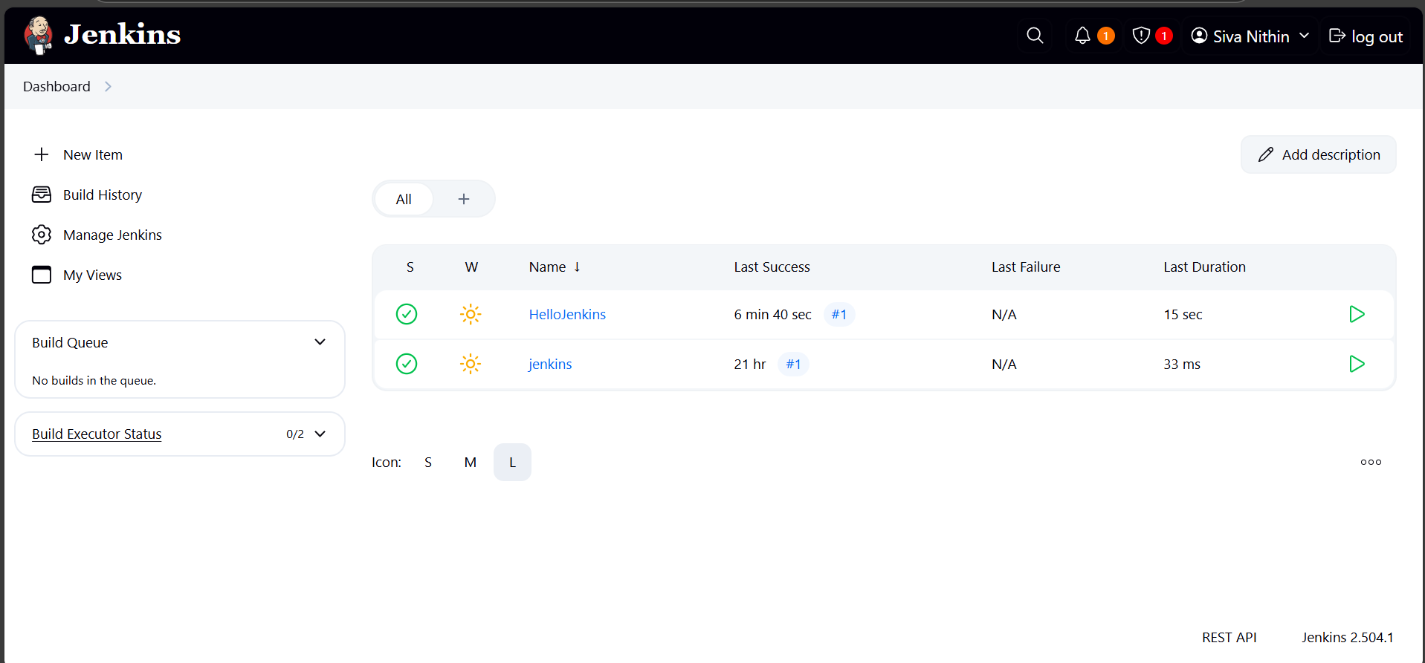

1. **Screenshot of your pipeline's successful execution (Stage View)**

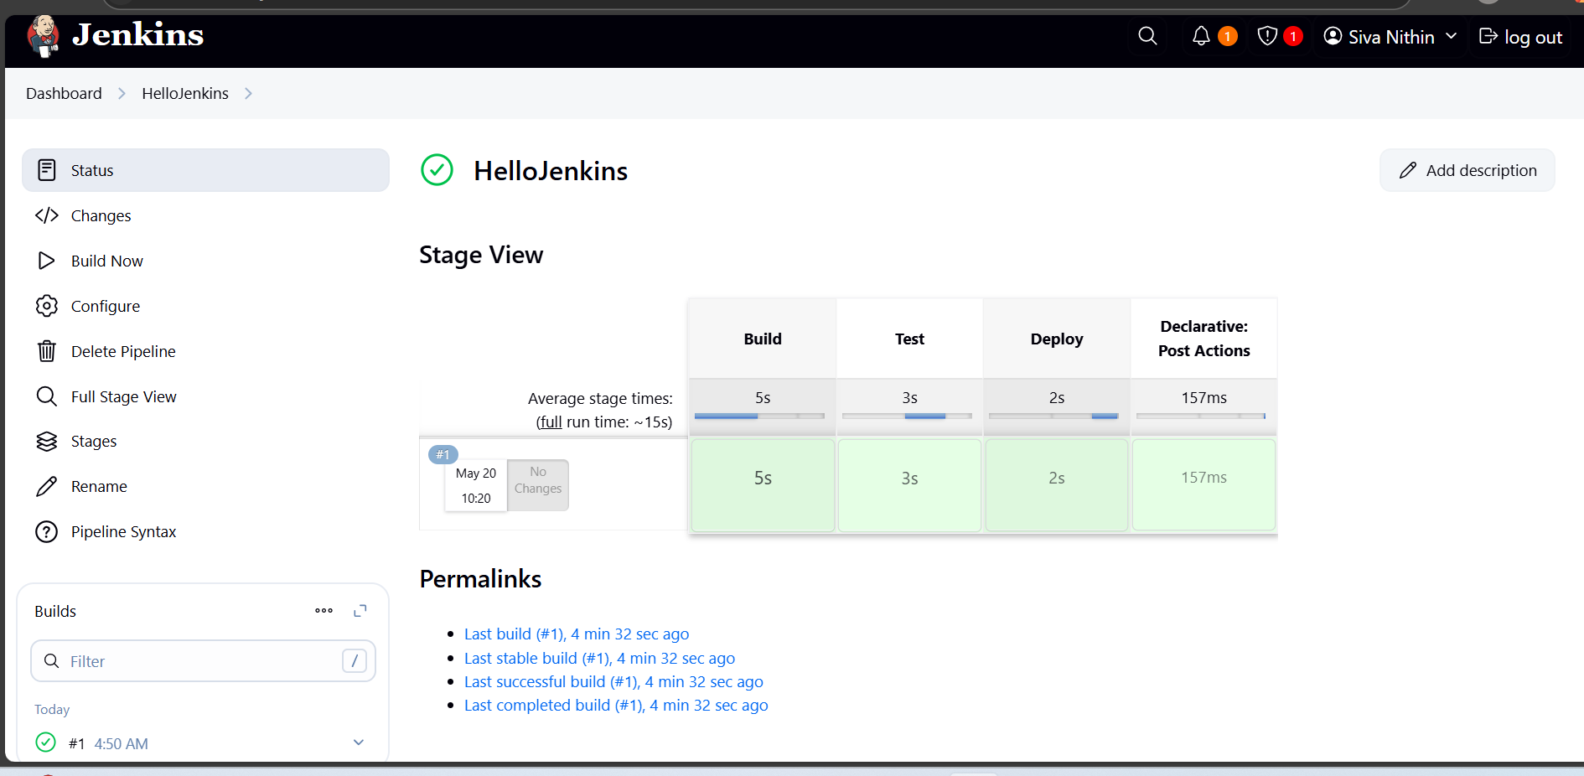

1. **Screenshot of the console output from one of your builds**

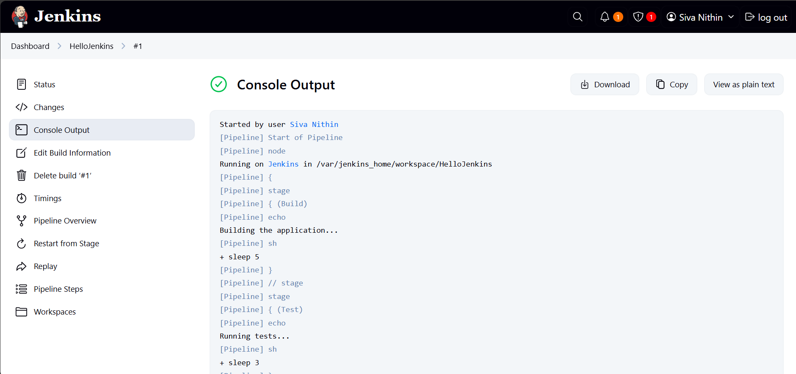

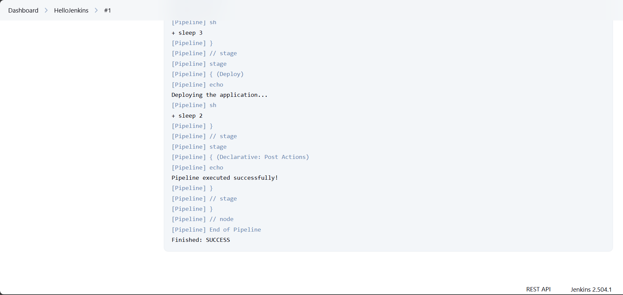

**Console output of new Stage   
  
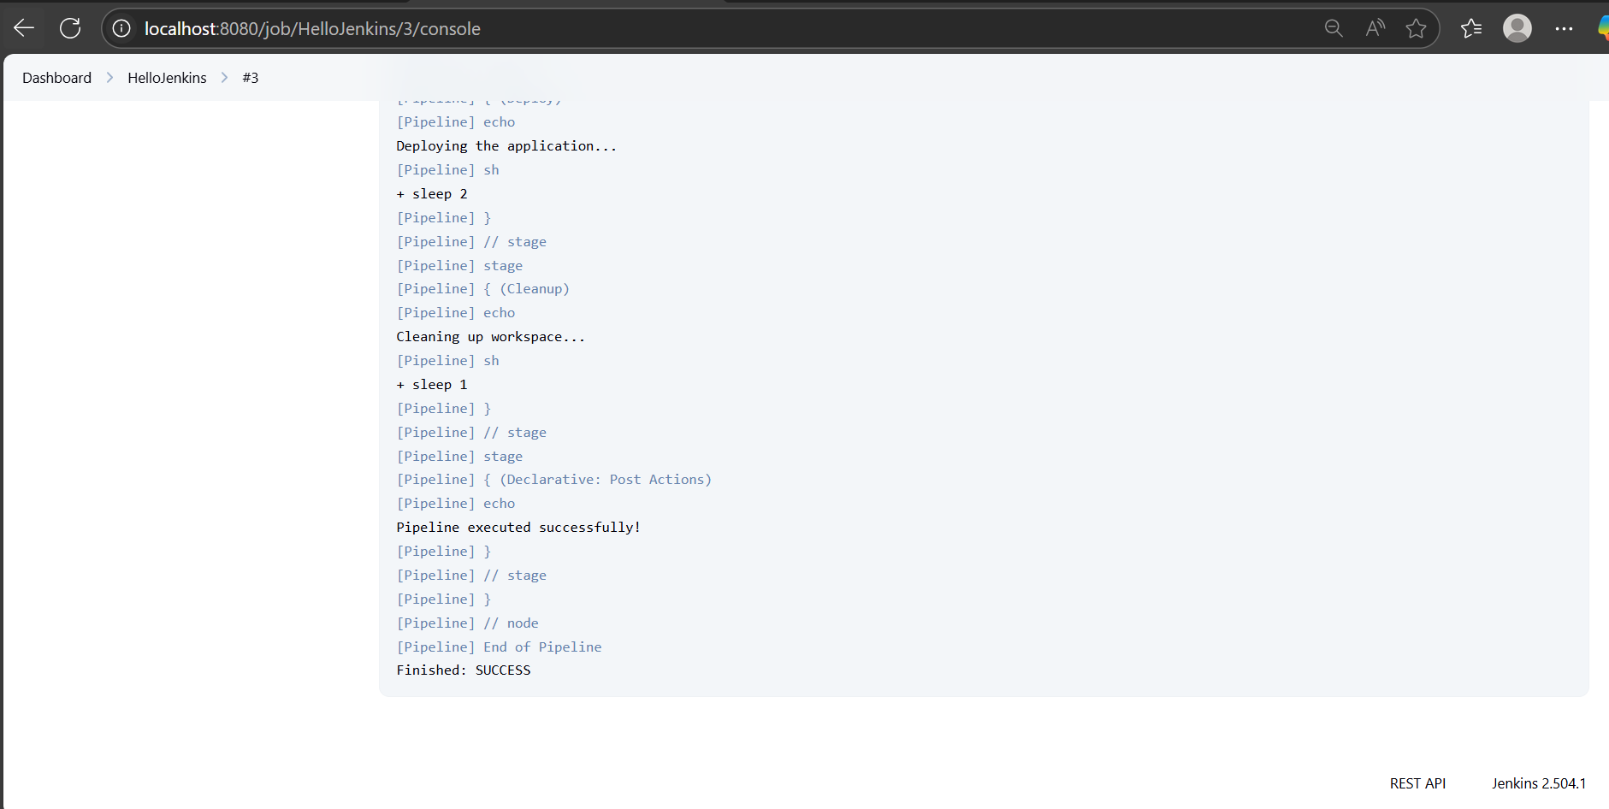  
  
Screenshot of Updated Stage View**

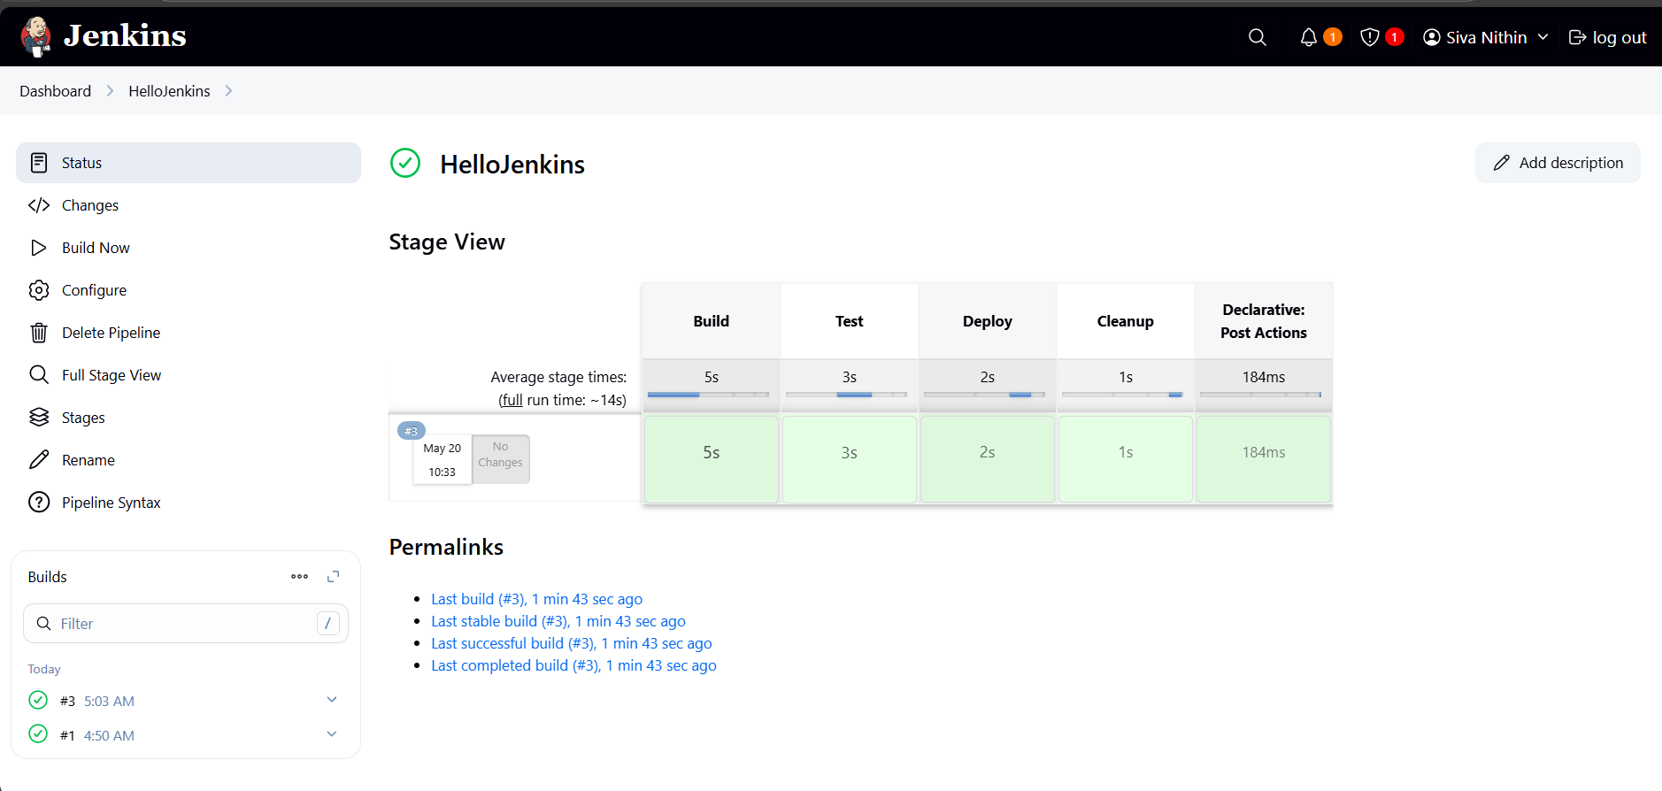

1. **Brief summary (3-5 sentences) describing what you learned about Jenkins navigation**

First, I checked out the Jenkins dashboard and understood where the jobs, build queue, and executors are shown. Then I created a pipeline job called "HelloJenkins" and added stages like Build, Test, Deploy, and later Cleanup. I ran the pipeline and used the Stage View to see how each stage is executed successfully. I also opened the Console Output to check the logs and messages printed during each stage.   
This whole process helped me understand how to navigate Jenkins, run jobs, and monitor everything clearly.